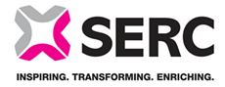
South Eastern Regional College Equality Screening Report
Period: 2023-24
Quarter 4: 1 May 2023 -31 July 2023
Policy Title | Aim of Policy | New / Existing / revised policy | Date of Screening | Screening Decision
None recorded | n/a | n/a | n/a | n/a

